

Fuel Oil Management Plan
© 2021 American Bureau of Shipping. All rights reserved

Table of Contents
Introduction 4
How to Use This Template 4
1 General Information 5
1. General 5
2. Development of the Fuel Oil Management Plan 5
2.1 General Contents of Plan 5
2.2 General Guidance for Using the Template 6
2 Fuel Oil Management Plan Template 7
1. Cover Page 7
2. Review and Revision History 8
3. Table of Contents 9
4. Introduction 10
5. Vessel Particulars 10
5.1 Machinery Particulars 11
6. SOx Emissions – Regulations/Requirements 12
7. Bunker Fuel Consumption Monitoring 14
7.1 General 14
7.2 Fuel oil consumption monitoring [revise as applicable] 14
7.3 Onboard Bunker Fuel Availability [revise as applicable] 14
7.4 Bunker Fuel Required for Voyage [revise as applicable] 14
7.5 Bunker Purchasing [revise as applicable] 15
7.6 Bunker Delivery Note (BDN) 15
7.7 Fuel Oil Availability 16
8. Actions Required Prior Bunkering 17
8.1 General Requirements 17
8.2 Bunkering Plan [revise as applicable] 17
8.3 Chief Engineer's Bunkering Orders [revise as applicable] 18
8.4 Watch Keeping/Duties [revise as applicable] 18
8.5 Communication [revise as applicable] 19
8.6 Training of Vessel’s Crew Involved in Bunkering [revise as applicable] 19
9. Actions Required During Bunkering [revise as applicable] 20
10. Actions Required Upon Completion of Bunkering [revise as applicable] 21
11. Sampling 21
11.1 Introduction 21
11.2 Definitions 21
11.3 Sampling Methods 22
11.4 Sampling and Sample Integrity 22
11.5 Sampling Location 23
11.6 Sealing of the Retained Sample 23
11.7 Retained Sample Storage 23
11.8 Handling and Retention of Bunker Samples [revise as applicable] 24
12. Fuel Switching Procedure 25
12.1 Fuel Change-over from HFO (Heavy Fuel Oil) to MGO (Marine Gas Oil) [revise as applicable] 25
12.2 Fuel Change-over Procedure for Auxiliary Engines, Boilers [revise as applicable] 26
12.3 Fuel Change-over Procedure with Different Type Fuels [revise as applicable] 26
12.4 IMO Record Keeping Requirements 26
12.5 EU Record Keeping Requirements 26
12.6 California Air Resources Board (CARB) Recordkeeping Requirements 27
13. Duties/Responsibilities 27
13.1 Operations Manager of the Company 27
13.2 Marine Superintendent of the Company 27
13.3 Master of the Vessel 28
13.4 Chief Engineer of the Vessel 28
13.5 Chief Engineer’s Responsibility to the Master 28
14 List of Drawings Required to Attach with the FO Management Plan 29
FOMP ANNEXES A - G 30

Introduction

How to Use This Template
Follow the instructions below to create and format your document. For questions and assistance reach out to graphics@eagle.org.
- Ignore the Table of Contents until you complete the rest of the document.
- Fill in your text starting either below these instructions or in place of them. Remember to delete the instructions later if necessary.
  - Use the Heading text style for major sections in your document. These will appear in your Table of Contents.
  - Use the Heading 2 text style for subheaders. These will also appear in your Table of Contents.
  - Use the Normal text style for all other text throughout the document. Paragraph headers may be bolded, and tables may use underlines as their headers.
- Once you’ve finished adding your text, update your Table on Contents by selecting Update Table of Contents at the top of the table or right clicking within the table and selecting Update Field.
- Update the copyright year at the bottom of the back cover page and verify that all contact information is up to date.

1 General Information
[Please delete this Section 1 on completion of the Template]

1. General
Vessels complying with Emission Control Area (ECA) fuel oil requirements by using fuel oil switching operations when entering or leaving an ECA are to include the following details in their fuel oil management plan:
- Vessel particulars,
- Schematic diagrams of the fuel oil system, including details of change-over for SOx control,
- Step-by-step fuel oil changeover procedures for main engine, auxiliary engines, boiler, etc.,
- Methods and means of recording volume of low-sulfur fuel oils in tanks,
- Date, time, and position of the vessel when any operation of fuel oil changeover is completed prior to entry into, or is commenced after exit from, an ECA,
- A statement that the bunker delivery note must be retained for a period of three years,
- Description of process for the sealing of a sample of the fuel oil delivered including signing by the supplier’s representative and retention onboard for 12 months,
- Course of action when purchase of compliant fuel oil is not available in accordance with the vessel’s voyage plan.

2. Development of the Fuel Oil Management Plan
There is no statutory requirement for a vessel to have a Fuel Oil Management Plan (FOMP); however, the FOMP template in Section 2 has been developed for the convenience of the ship owner/operator. The FOMP covers the requirements of Regulation 14 & 18 of MARPOL Annex VI, MEPC.182(59), EU Directives, 13 CCR (Code of California Regulation) and ABS Guide for the Environmental Protection Notation for Vessels. The template provides assistance in the development of a vessel-specific FOMP based on the fuel oil piping system, main & auxiliary engines and other related equipment.
The FOMP template should be written in the working language of the vessel. (If the language used onboard is not English, French or Spanish, a translation into one of these languages is to be made.)

2.1 General Contents of Plan

The FOMP contains information on handling fuel oil based on the above requirements in order to operate a vessel effectively in all waters, including emission regulated waters. The plan contains the following information:
- Ship particulars,
- Index of sections for referencing the contents of the plan,
- Introduction or explanation of the need for fuel oil management,
- Regulations/requirements, bunkering details,sampling details,
- Description of ship’s fuel oil change-over procedure,
- Method of record keeping of low sulfur fuel volume, date, time and location of fuel switching.

2.2 General Guidance for Using the Template

<Fields highlighted in yellow> are comments, suggestions or example text that need to be deleted and may require the user’s input, in which case they are to be filled out accordingly.
Users are recommended to review the contents for relevance and applicability to the topics or subject headings that are being developed for specific vessels.

2 Fuel Oil Management Plan Template

Cover Page

Fuel Oil Management Plan

<Vessel Name>
<IMO Number>

To meet the requirements of the Regulation 14 & 18 of MARPOL Annex VI and ABS Guide for the Environmental Protection Notation for Vessels

Issued Date: _____<xxxxxxx>_____
Owner/Operator: _____<xxxxxxx>_____

Review and Revision History
On a routine basis, the owners/operators and vessel’s crew are to review the contents of the FOMP. This review is to confirm that the information provided within the Plan is current and contains the information necessary to conduct a fuel switching operation in order to comply with applicable sulfur regulations such as of IMO MARPOL Annex VI, EU Directives, California Air Resources Board (CARB) and ABS Guide for the Environmental Protection Notation for Vessels. A record of the periodic reviews of the Plan by the crew and revisions to the Plan are to be recorded in the tables below.
This section documents a review by the vessel’s crew and provides a means to track the revision history of the ship’s FOMP as a means to confirm that the FOMP remains current.

Review History
Name | Position/Rank | Date of Review | Signature
<xxxx> | <xxxx> | <xxxx> | <xxxx>
<xxxx> | <xxxx> | <xxxx> | <xxxx>
<xxxx> | <xxxx> | <xxxx> | <xxxx>

Revision History
Current  Version | Previous  Version | Date of  Revision | Created by  (Name/Rank) | Description of Revision
<xxxx> | <xxxx> | <xxxx> | <xxxx / xxx> | <xxxx>
<xxxx> | <xxxx> | <xxxx> | <xxxx / xxx> | <xxxx>
<xxxx> | <xxxx> | <xxxx> | <xxxx / xxx> | <xxxx>

Table of Contents
A Table of Contents is an index of the information provided, allowing users to quickly navigate and reference various sections of the Plan.
An example is given below. [Replace as deemed appropriate.]

Table of Contents
Page
Cover Page 3
Review Record/Revision History 4
Table of Contents 5
Introduction 6
Vessel Particulars 7
SOx Emission – Regulations/Requirements 8
Bunker Consumption Monitoring 9
Actions Required Prior Bunkering 11
Actions Required During Bunkering 13
Actions Required Upon Completion of Bunkering 14
Sampling 16
Fuel Switching Procedure 19
Machinery Particulars 19
Duties/Responsibilities 21
Drawings to attach with this FO Management Plan 22

Introduction
At the beginning of each FOMP an “introductory” section should be included to reflect the intent of Regulations and the purpose of the plan.
<Name of the shipping company> has developed a proactive approach for environmental management that includes the identification and assessment of sources for marine and atmospheric pollution. This plan supports the reduction of harmful SOx and PM emissions through effective fuel oil management including best practices for fuel oil change-over procedures.
The purpose of the FOMP is to promote compliance with Regulations 14 and 18 of MARPOL ANNEX VI. This includes procedures for fuel bunkering, bunker quantity measurement and storage management, sampling, recordkeeping/Bunker Delivery Notes (BDN)s and change-over procedures in order to identify potential problems before they impact the ship’s operation, and to ensure that:
- Interaction of the shipboard activities with the environment is in accordance with the applicable mandatory rules and regulations and any additional requirements imposed for retaining the ENVIRO or ENVIRO+ notation from the ABS.
- Shipboard emissions/discharges to the sea, air and land are controlled, monitored and in accordance with the company‘s policies and objectives.
All vessels are required to minimize pollution to the atmosphere. The purpose of these instructions is to describe the procedures that must be followed for the control of SOx and PM emissions, thereby limiting harmful air pollutants.
[In addition, the user may consider expanding this “introductory” section to explain their company specific needs for a FOMP]

Vessel Particulars

Vessel particulars are to include at least the following:
Ship‘s name
Flag
Port of Registry
IMO number
Call sign
Type of Ship
Maritime Mobile Service Identity (MMSI)
Length overall (LOA)
Length between perpendiculars (LBP)
Breadth (m)
Depth (m)
Deadweight (dwt)
Gross tonnage (grt)
Net tonnage (nrt)
Summer draft
Engine Type
RPM
Power
Class
Class ID
Builder and date of build

5.1 Machinery Particulars
List of main and auxiliary engines and auxiliary boilers:
 | Make | Model | Serial No. | Rated Power
Main Engine1 |  |  |  | HP @.....RPM
Main Engine 2 |  |  |  | HP @.....RPM
Auxiliary Engine 1 |  |  |  | HP @.....RPM
Auxiliary Engine 2 |  |  |  | HP @.....RPM
Auxiliary Engine 3 |  |  |  | HP @.....RPM

 | Make | Model | Serial No. | Rated Output
Aux. Boiler 1
Aux. Boiler 2

SOx Emissions – Regulations/Requirements
Air pollution concern have grown and as a result many regulations and requirements have been set forth in order to minimize the release of harmful substances in the atmosphere.
There are several unwanted and potentially harmful combustion by-products released into the atmosphere as part of the combustion of fossil fuels (petroleum products, gas etc.) including: Sulfur Oxides (SOx) have a direct health impact. Exhaust gases also contain PAH and PM, which have been known to be carcinogenic.
Some of these emissions are attributed to badly tuned engines and poor combustion. However, some emissions are inherent in the nature of fuel oil. One such element is sulfur, which is present in fuel oil and, upon combustion, produces sulfur oxide (SOx) and sulfur dioxide (SO₂), both acidic in nature. SOx rise, dissolve, and mix with the atmosphere to form more acidic pollutants, known as “acid rain”, and can readily travel over land and sea.
MARPOL Annex VI sets limits on sulfur oxide and nitrogen oxide emissions from ship exhausts and prohibits the use of ozone depleting substances. Regulation 14 of MARPOL Annex VI, SOx Emissions, provides a step approach to sulfur in fuel reductions. The Regulation established a global limit of 3.50% m/m sulfur content in all grades of fuel oil used on ships, effective 1 January 2012. This limit is scheduled to be further reduced to 0.50% m/m on 1 January 2020. However, the implementation date may be delayed based upon an IMO review of global fuel availability, which is planned for 2018.
Regulation 14 of Annex VI also contains provisions for nations to apply to the IMO for designation of special areas where harmful emissions from ships can be further limited. As of 1 January 2015, a 0.10% m/m sulfur in fuel limit is in effect for operation in Emission Control Areas (ECAs).
The first two Emission Control Areas approved by the IMO addressed SOx emissions, and are known as SECAs. They are: the Baltic Sea and the North Sea (including the English Channel). The IMO has also approved two more ECAs, setting limits for SOx, NOx and PM. These areas are the North American and US Caribbean Sea.
The EU (European Union) Directive 2005/33/EC went into effect 1 January 2010 and requires vessels berthed in an EU port to use maximum 0.1% m/m sulfur content fuel.
13 CCR (Code of California Regulation), Section 2299.2 restricts marine fuels used when entering any waters within 24 nautical miles of the California baseline to use distillates with maximum 0.1% sulfur content and went into effect 1 January 2014. This California Regulation is implemented through the “Fuel Sulfur and Other Operation Requirements for Ocean-Going Vessels within California Waters and 24 Nautical Miles of the California Baseline” (or, the Ocean Going Vessel (OGV) Fuel Regulation).
The CARB OGV Fuel Regulation does not currently recognize or permit the use of non-distillate low sulfur fuels or alternative emission control technologies (i.e., EGCS) for compliance with the sulfur reduction limits.
Operators entering waters of the State of California should be aware they must comply with both the California OGV Fuel Regulation and the North American ECA requirements. All engines and boilers, except main propulsion boilers, are affected by the regulations and it is mandatory to operate engines and auxiliary boilers on low sulfur marine fuel with the sulfur content as indicated in the respective regulations.
SOx compliance dates for Regulation 14 of MARPOL Annex VI, CARB and EU
IMO Global |  | SECA/ECA |  | CARB (24nm of CA Baseline) |  | EU
Date | Sulfur % | Date | Sulfur % | Date | Sulfur % | Date | Sulfur %
1 Jan 2012 | 3.5% | 1 Jul 2010 | 1.0% | 1 Jan 2014 | 0.1%  (Distillate FO) | 1 Jan 2010 | 0.1%  (in port)
*1 Jan 2020 /2025 | 0.5% | 1 Jan 2015 | 0.1% |  |  | 1 Jan 2020 | 0.1%  (all EU waters)

* Subject to a review of the global availability of compliant fuel oil.

Bunker Fuel Consumption Monitoring

7.1 General

Fuel oil constitutes a very significant expense to a ship’s operation and therefore effective management controls should be exercised over its consumption. Ship efficiency has a direct connection to controlling and preventing energy loss and, ultimately, conservation of natural resources.

7.2 Fuel oil consumption monitoring [revise as applicable]

The performance of all ships is to be monitored very closely, on a daily basis, to ensure that the desired level of engine efficiency is being achieved.

7.3 Onboard Bunker Fuel Availability [revise as applicable]

The status of fuel available onboard is monitored by the Operations Manager/Chief Engineer (as per company policy) by reference to the daily sounding report. The Master is responsible to ensure that his vessel has sufficient fuel to safely carry out the proposed voyage. Voyage planning must take into account the following:
- Length of the voyage;
- Expected prevailing weather conditions;
- Expected consumptions during the proposed voyage;
- Speed, condition of the vessel (laden or ballast condition);
- Operations required underway (tank cleaning, heating, etc.);
- Availability or not of receiving additional bunkers as needed during the voyage;
- Quality of the fuel, as specified in the MARPOL Annex VI requirements; and

7.4 Bunker Fuel Required for Voyage [revise as applicable]

When voyage orders are received, the Chief Engineer (C/E) must advise the Master on the amount of fuel currently on board and the anticipated daily consumption for the forthcoming voyage. The C/E must also advise the Master of the amount of fuel estimated to be consumed for non-propulsion purposes during the intended voyage. From this information the Master and C/E must determine the ship’s fuel requirements. The voyage orders will indicate whether one way or round-trip bunkers are to be taken and whether any limitations as to fuel requirements exist. Prior to sailing, the Master is to ensure that adequate fuel is onboard for the planned voyage, plus a safe margin of reserve.

Heavy Fuel Oil
Unless instructed to the contrary by the Company, a minimum safe reserve of Heavy Fuel Oil (HFO) should be a seven (7) days open sea sailing at normal speed consumption quantity. In any case, the safe margin of reserve should not be less than 3 days consumption, but only in exceptional circumstances could be more than 7 days.

ECA Compliant Fuel Oil
A vessel transiting an IMO Emission Control Areas (ECA) or other air emission restricted areas (EU, State of California) will need to use fuel with a maximum sulfur content. Distillate fuel or another ECA compliant fuel of sufficient quantity to complete transit through the ECA, or to a location where additional compliant fuel may be received, will be necessary.
If the fuel oil inventory varies significantly from the voyage order requirements upon sailing, the ship’s Operations department must be advised immediately.

7.5 Bunker Purchasing [revise as applicable]

Bunkering of a vessel on a Voyage Charter is organized by the company’s Operations department, or as specified in company’s written policy. Fuel oil is required to meet certain specifications and should be in accordance with Regulation 18 of MARPOL Annex VI, and ISO 8217. It should be noted that ECA compliant fuels are not developed to ISO standards due to a viscosity higher than distillate fuels.

7.6 Bunker Delivery Note (BDN)

The BDN is an important and statutory document that must be retained onboard for inspection purposes for a minimum period of three years from the time of bunkering. Appendix V of MARPOL Annex VI defines the following minimum information that is required to be contained in the BDN:
- Name and IMO number of the receiving vessel;
- Port of bunkering;
- Date of commencement of bunkering;
- Name, address and telephone number of the marine fuel supplier;
- Product name(s);
- Quantity of bunkers delivered/received in metric tonnes;
- Density at 15⁰ C (kg/m3) by hydrometer method (ISO 3675);
- Sulfur content (%m/m) by x-ray fluorescence spectrometry (ISO 8754).

In addition to the above information, the BDN, or a separate declaration signed and certified by the fuel oil supplier's representative, is to state that the fuel as supplied to the ship is in conformance with Regulation 14.1 or 14.4 and Regulation 18.3 of MARPOL Annex VI.

As the BDN may be inspected by Port State Control officers, particularly within ECAs, the accuracy of the information contained in these records are paramount as they provide clear evidence of the quantity of the low sulfur fuel (less than 0.1% sulfur) received by a vessel. The BDN must never be signed before the completion of the bunkering operation and shall be kept on board the ship in such a place as to be readily available for inspection at all reasonable times. BDNs are to be retained for a period of three years after the fuel oil has been delivered on board.

The BDN shall be accompanied by a representative sample of the fuel oil delivered, taking into account Resolution MEPC.182(59) – 2009 Guidelines for the Sampling of Fuel Oil for Determination of Compliance with the Revised MARPOL Annex VI – (Adopted on 17 July 2009). The sample must be sealed and signed by supplier’s representative and the Master or Officer in charge of the bunker operation, and must be retained onboard ship for at least 1 year from the date of delivery. See a sample BDN in FOMP ANNEX A.

7.7 Fuel Oil Availability

Where fuel oil complying with the table in paragraph 6 above is not available at a bunkering port or terminal, the course of action should include any combination of, but not be limited to, the following:
- Bunker the minimal amount of fuel oil necessary to proceed to a port or terminal where compliance fuel oil can be obtained;
- Carriage of sufficient amounts of Marine Distillate Fuels, such as grades DMA, DMB, and DMC of ISO 8217, in appropriate bunker tanks;
- Use of exhaust gas cleaning systems.

Upon receiving fuel oil not in compliance with the limits above, the following is to be recorded in the appropriate vessel’s log:
- Date, time, and name of port or terminal;
- Sulfur content as indicated on the BDN;
- List of fuel oil tanks bunkered with non-compliant fuel oil;
- Volume of non-compliant fuel oil in each tank.

The vessel, prior to entering the:

- North American ECA is required to report use of non-compliant fuel to the EPA and authorities at the relevant port of destination, using the EPA’s Fuel Oil Non-Availability Report (FONAR).
- Baltic and North Sea areas need to provide evidence that it attempted to purchase compliant fuel oil in accordance with its voyage plan and that, despite best efforts, no such fuel oil was made available for purchase.

Actions Required Prior Bunkering

General Requirements

Whenever a vessel takes bunkers, the operation must be carefully planned and executed in accordance with all applicable international and national regulations and standards (e.g. SS 600:2008). The C/E is directly responsible for all bunkering operations, bearing in mind that the Master carries ultimate responsibility.
In cases where more than one type of fuel (e.g. HFO & MGO) is to be bunkered, then each type of fuel shall be separately, and not simultaneously, transferred on board. The sequence of these operations shall be determined with this purpose (one type of fuel to start being bunkered after the other type has been fully transferred onboard) and as a result any simultaneous bunkering is to be avoided.
In cases where simultaneous bunkering cannot be avoided, an approval from the Company’s appropriate department shall be obtained in writing.
See bunkering pre-delivery safety checklist, included here as FOMP ANNEX C.

8.2 Bunkering Plan [revise as applicable]

Bunkering operations shall always be carried out in accordance with a written plan. The C/E shall prepare a bunkering plan and should ensure that it is discussed with all personnel involved in bunkering operations and posted in a location where it can be easily seen.
The bunkering plan at a minimum must include:
- Identification, location, and capacity of the bunker tanks receiving oil (It is stressed that any reference to bunkers capacity always refer to 90% of the total bunker storage capacity, i.e. with each bunker tank being 90% full);
- Level and type of liquid in each bunker tank at the scheduled time of bunkering;
- Planned final ullage or innage, and percent of each tank to be filled;
- Sequence in which tanks are to be filled;
- Procedure to regularly monitor all bunker tank levels and valve positions;
- Procedure to identify and verify the correct position of all bunker and fuel transfer valves;
- Identification of the bunkering rate that can be safely monitored by the involved personnel and will not exceed the capacity of the venting system;
- Procedure to check bunker tank ventilation arrangements;
- Procedure to check internal tank overflow arrangements;
- Verification of gauging system operation and accuracy;
- Procedure to check alarm settings on overfill alarm units;
- Procedures and methods for changing over tanks during bunkering.
It should be noted that when preparing the bunkering plan, the C/E should consider the following:
- The distribution of bunkers which should ensure the vessel’s safe condition bearing in mind the trim of the vessel prior and after the bunkering;
- The segregation of bunker, in order to avoid the potential consequence of incompatibility from the mixing of different fuels, whenever this is possible. This also provides the opportunity to confirm the extent of fuel quality by drawing separate tank samples should the need arise;
- A sufficient quantity of previous bunkers should be ensured, to allow for a reasonable cross over period from old to new bunkers, thus providing time for an independent assessment of the new bunker quality before it is put into use;
- A diagram of the fuel oil transfer piping is recommended to be attached to the plan.

8.3 Chief Engineer's Bunkering Orders [revise as applicable]

It is essential that the Chief Engineer’s written standing orders for bunkering operations are posted at the fueling station or control room in a language understood by the crew. These orders should include:

- Schematic fuel oil piping diagrams including location of all valves, pumps, controls, vents and overflow systems;
- Person in charge of the bunkering operation;
- Persons required to be on duty during bunkering operations and details of respective duties;
- Procedures for emergency shutdown;
- Topping-off procedures;
- Valve closing procedures;
- Reminder to plug all scuppers;
- Ship/shore (barge) communication procedures;
- Reminder to inspect condition of hoses;
- Sampling procedures.

8.4 Watch Keeping/Duties [revise as applicable]

The C/E must ensure that, prior to commencing bunkering operations, at least the following duties have been assigned to qualified crew members:

- Deck watch keeper: The primary duty of the deck watch keeper is to monitor for oil spills on deck or over the side during bunkering. The deck watch keeper may perform other duties not in conflict with his primary duty. The deck watch keeper shall (a) visually inspect the deck and water near or opposite all bunker tanks and each tank's sounding tube and vent, if accessible; and (b) remain in a position during changing over of tanks or topping off to view any spillage on deck or in the water;
- Watch keeper at bunker connection: The bunker connection watch keeper will be responsible to remain at the point of connection and to communicate with the delivering vessel. He should check the proper operation of the drip line sample valve and ensure that no tampering of the sample occurs;
- Tank watch keeper: The tank watch keeper is responsible to take and communicate soundings of tanks being filled to the Person in Charge. The C/E should ensure that that he receives sounding reports on tank levels according to the monitoring procedure established in the vessel's pre-loading bunkering plan.
Pipeline and valve settings shall be verified by Chief Engineer and Engine Room Officer of the Watch.
Except for the deck watch keeper, personnel assigned bunkering responsibilities may perform only those duties assigned while the vessel is bunkering. All personnel assigned to bunkering shall comply with their duties identified in the vessel's bunkering procedure and shall remain at their work stations during topping off.

8.5 Communication [revise as applicable]

Each involved person should be equipped with two-way communication in order to ensure effective communication.

The C/E shall ensure that communication between the vessel and delivering vessel or facility is accomplished visually or by voice, sound-powered phones, radio, air horn. The C/E shall notify the delivering vessel's or facility's Person in Charge before any topping off begins.

The C/E shall ensure that bunkering personnel know and use English phrases and hand signals to communicate the following instructions during bunkering: "stop," "hold," "okay," "wait," "fast," "slow," and "finish."

8.6 Training of Vessel’s Crew Involved in Bunkering [revise as applicable]

A training/familiarization session is to be conducted 48 hours prior to any scheduled bunkering for all vessel personnel involved in bunkering duties. None of the crew members should assume any bunkering responsibilities without appropriate training. The C/E is responsible for such training. The training session shall include, but is not limited to:

- Review of bunkering plan (see section 8.2);
- Review of any penalties and liabilities for not complying with any national and/or international regulations and/or for spilling oil in waters;
- Discussion of vessel's fuel oil transfer procedure;
- Discussion of every person's responsibilities and station;
- Dissemination of instructions to all personnel to remain at assigned locations during topping off;
- Review of the communication methods to be used between receiving and delivering vessel, including English phrases and hand signals for: “Stop”, “Hold”, “Okay”, “Wait”, “Fast”, “Slow”, and “Finish”. See a sample of hand signals in FOMP ANNEX B;
- Review of the emergency shutdown procedures;
- Review of the risk control measures set out in the Company’s written procedure;
- Review and completion of the Bunker Safety Check list.

Actions Required During Bunkering [revise as applicable]
During bunkering the C/E should ensure/check the following:
- Rounds are conducted frequently to check bunker hoses and connections for possible leakages;
- The bunkering transfer line is continually monitored while the operation is in progress;
- That all alarms are answered and any abnormalities are investigated and corrected;
- And verify remote gauges by manual gauging, especially when starting up and topping off;
- To adjust the flow rate as required to avoid the possibility of spills when topping off tanks;
- Any unused manifold connections are blanked and fully bolted;
- That ample warnings are given to the terminal/barge during the final stages of bunkering and before the final notification for the interruption of the flow. The signal to finish the fuel oil flow must be given by the ship;
- Ample ullages are provided in each tank to allow for temperature variations of the bunkers
- Ample ullage is to be left in the last tank loaded, to allow for draining of the hoses and for relief of the air locks in the system;
- There is always a crew member on watch at the bunker manifold to check the proper operation of the drip line sample valve and ensure there will be no tampering with the sample;
- The ullage of the fuel tank being loaded is monitored regularly (at intervals not exceeding 30 minutes);
- The ullages of other tanks connected to the same line are regularly checked to ensure no accidental leakage is occurring;
- The bunkering operation ceases in the event of heavy rain and an electrically charged atmosphere;
- The next tank valve is opened before the previous tank valve is closed during loading tank change-over;
- The person who is taking tank ullages is given regular breaks by a backup person if bunkering operation is anticipated to be carried out for longer than [x] hour(s).

Actions Required Upon Completion of Bunkering [revise as applicable]
On completion of bunkering, the C/E should ensure that the following items are carefully completed/checked:
- Visually confirm that the transfer pump has stopped. Isolate and tag out any remote pumps, e.g. the forward transfer pumps;
- Empty any oil that has collected in the fixed or portable containment systems (such as bunker, excess oil) and transfer the contents into a suitable tank;
- Thoroughly drain any lines and close all valves that were opened during the operation;
- Ensure that all tank gauges and sounding pipes are in the normal condition;
- Inform all parties that the transfer operation is complete;
- Hoses are drained before disconnecting. Do not permit the barge/facility to blow (purge) the bunker line;
- Bunker system valves are closed;
- Hoses are blank flanged or otherwise sealed before being removed;
- The fuel sample container seal is broken and the required samples are taken in accordance with Section 12;
- Bunker system connections are blank flanged as soon as hoses are disconnected;
- Final soundings of all fuel oil tanks have been taken. Ensure ample ullage space for expansion;
- Bunkering and BDN details recorded.

Sampling

11.1 Introduction

In accordance with Regulation 18.8.1 of MARPOL Annex VI and Resolution MEPC.182(59), the BDN shall be accompanied by a representative sample of the fuel oil delivered. This sample is to be used solely for determination of compliance with MARPOL Annex VI.

11.2 Definitions

For the purpose of these Guidelines:

- Supplier’s representative is the individual from the bunker tanker who is responsible for the delivery and documentation or, in the case of deliveries direct from the shore to the ship, the person who is responsible for the delivery and documentation;
- Ship's representative is the ship's Master or officer in charge who is responsible for receiving bunkers and documentation;
- Representative sample is a product specimen having its physical and chemical characteristics identical to the average characteristics of the total volume being sampled;
- Primary sample is the representative sample of the fuel delivered to the ship collected throughout the bunkering period, obtained by the sampling equipment positioned at the bunker manifold of the receiving ship;
- Retained sample is the representative sample in accordance with Regulation 18.6 of MARPOL Annex VI, of the fuel delivered to the ship derived from the primary sample.

11.3 Sampling Methods

The primary sample should be obtained by one of the following methods:

- Manual valve-setting continuous-drip sampler; or
- Time-proportional automatic sampler; or
- Flow-proportional automatic sampler
Sampling equipment should be used in accordance with manufacturer’s instructions, or guidelines, as appropriate.
The amount of primary sample collected during bunkering should be checked at the end of the bunkering operation to ensure it is about 5 liters. This sample should be uniformly mixed and divided into sub-samples, i.e. sample retained to meet MARPOL requirement and commercial samples (Fuel Oil Analysis Laboratory sample, Fuel Oil Analysis Laboratory ship retained sample and sample for the supplier). The collected sample is to be divided into sub-samples in the presence of the supplier’s representative and sealed as per paragraph 11.6.
The primary sample must be representative of the whole period of bunkering from the unique source (i.e. if there are more than one bunker barge with more than one BDN, then one sample must be taken for the delivery of fuel associated with each BDN).

11.4 Sampling and Sample Integrity

A means should be provided to seal the sampling equipment throughout the period of supply. Attention should be given to:

- The form of set up of the sampler;
- The form of the primary sample container;
- The cleanliness and dryness of the sampler and the primary sample container prior to use;
- The setting of the means used to control the flow to the primary sample container;
- The method to be used to secure the sample from tampering or contamination during the bunker operation.
The sample receiving container should be attached to the sampling equipment and sealed so as to prevent tampering or contamination of the sample throughout the bunker delivery period. The container intended to hold the retained sample should be thoroughly inspected for cleanliness and dryness prior to collecting samples from the supplier. The sample retained for MARPOL purposes should be of sufficient quantity to perform the tests but should not be less than 400 ml. The container should be filled to 90% ± 5% capacity and sealed. One more sample shall be collected when a testing laboratory is engaged.

11.5 Sampling Location

In accordance with Regulation 18.8.1 of MARPOL Annex VI and Resolution MEPC.182 (59), a sample of the fuel delivered to the ship should be obtained at the receiving ship’s inlet bunker manifold and should be drawn continuously throughout the bunker delivery period.
The above phrase “be drawn continuously throughout the bunker delivery period” means a continuous drip sample collected throughout the bunker fuel delivery and covering each bunker delivery note. In case of receiving an amount of bunker fuel necessitating two or more delivery notes, the sampling work may be temporarily stopped to change sample bags and bottles and then resumed as necessary.

11.6 Sealing of the Retained Sample

Immediately following collection of the retained sample, a tamper proof security seal with a unique means of identification should be installed by the supplier’s representative in the presence of the ship's representative. A label containing the following information should be secured to the retained sample container:
- Location at which, and the method by which, the sample was drawn;
- Date of commencement of delivery;
- Name of bunker tanker/bunker installation;
- Name and IMO number of the receiving ship;
- Signatures and names of the supplier’s representative and the ship's representative;
- Details of seal identification;
- Bunker grade.
To facilitate cross-reference details of the seal, identification may also be recorded on the BDN. See an example of retained sample label in FOMP ANNEX D.

11.7 Retained Sample Storage

The retained sample should be kept in a safe storage location, outside the ship’s accommodation, where personnel would not be exposed to vapors which may be released from the sample. Care should be exercised when entering a sample storage location.
The retained sample should be stored in a sheltered location where it will not be subject to elevated temperatures, preferably at a cool/ambient temperature, and where it will not be exposed to direct sunlight.
Pursuant to Regulation 18.8.1 of MARPOL Annex VI, the retained sample should be retained under the ship’s control until the fuel oil is substantially consumed, but in any case for a period of not less than 12 months from the time of delivery.
The ship’s Master should develop and maintain a system to keep track of the retained sample.
After the retention period of 12 months expires, the C/E is responsible to collect the expired samples from their storage location and to dispose them into the sludge tank through the sounding pipe.
See an example format of fuel sample tracking/control in FOMP ANNEX E.

11.8 Handling and Retention of Bunker Samples [revise as applicable]

The samples collected for testing purposes (Fuel Oil Analysis Laboratory sample, Fuel Oil Analysis Laboratory ship retained sample and sample for the supplier) are to be sealed and signed by both parties. These samples should be collected during every bunkering operation.
The Fuel Oil Analysis Laboratory sample should be enclosed with a copy of the bunker receipt and appropriate forwarding instructions and sent to the nearest Fuel Oil Analysis Laboratory testing station via the local agent without delay upon completion of bunkering.

Fuel Switching Procedure
The fuel change-over procedure shall be completed before the vessel enters into any ECA or exhaust emission control area (i.e., 24 nautical mile shore area of the California baseline). In EU ports the crew is to complete any necessary fuel change-over operation as soon as possible after arrival at berth and as late as possible before departure from the berth.

12.1 Fuel Change-over from HFO (Heavy Fuel Oil) to MGO (Marine Gas Oil) [revise as applicable]

In order to use MGO (0.1% Sulfur FO) as fuel, every vessel is to be fitted with dedicated low sulfur fuel oil storage tank, fuel oil piping system arranged to operate low-sulfur fuel for main engine, auxiliary engines, and boiler etc. Additionally, operational procedures for fuel change-over are to be provided on board the vessel.

An example of Fuel Oil Change-over procedures are provided below for a typical vessel where a dedicated MGO tank is provided; however, fuel oil change-over procedures are very specific for each vessel based on the fuel piping design, type of main engine, auxiliary engines, boilers etc. The vessel owner/operator is required to develop vessel specific change-over procedures by consulting with the designer of the fuel piping system and manufacturers of the engines and boilers.

- Main Engine (M/E) Fuel Oil (FO) Change-over procedure from HFO to MGO:

- Verify MGO service tank level,
- Reduce M/E load to 25~40% of normal load,
- Stop all steam tracing for M/E FO service system, auto filter etc. and switch temperature control valve to manual,
- Change-over switch from HFO to MGO in the control panel ,
- When viscosity is around 6 cSt, open M/E MGO cooler inlet valve ,
- Slowly close HFO heater inlet valve for smooth temperature change at a rate of about 2º C per minute,
- Viscosity is to be kept all time in between 2 – 20 cSt,
- Use stand-by FO supply and circulating pump to flush the system with MGO,
- Viscosity and pressure of supply and circulating line is to be checked,
- Once system has stabilized, open MGO return valve and close HFO return valve.
- Adjust separators according to LSFO density and viscosity. Continuous transfer LSFO from settling tank to service tank by using separator(s)
- Change-over completed when the sulfur level in the service tank and fuel oil service piping system up to and including consumers has reached 0.1%. Date and time, ship position and low sulfur fuel oil in each tank onboard, is to be recorded in suitable log book as prescribed by the Administration upon completion of change-over.

- Main Engine (M/E) Fuel Oil (FO) Change-over procedure from MGO to HFO:

- Verify HFO service tank level,
- Reduce M/E load to 25~40% of normal load,
- Open HFO return valve and close MGO return valve,
- Change-over switch from MGO to HFO in the control panel,
- Close M/E MGO cooler inlet valve; when viscosity reaches around 6 cSt, open FO heater inlet valve,
- When viscosity is around 10 cSt, open all steam tracing valves of service system, auto filter etc. and temperature control valve to auto for smooth temperature change at a rate of about 2º C per minute,
- Viscosity is to be kept all time in between 2 – 20 cSt,
- Viscosity and pressure of supply and circulating line is to be checked,
- Date and time, ship position and low sulfur fuel oil in each tank onboard, is to be recorded in suitable log book as prescribed by the Administration upon beginning of change-over.

Fuel Change-over Procedure for Auxiliary Engines, Boilers [revise as applicable]

Similar types of change-over procedure like above example are required to be developed for auxiliary engines and boilers.

Fuel Change-over Procedure with Different Type Fuels [revise as applicable]

If the vessel is using different types of fuels e.g. HFO, MGO, MDO or recently offered ECA compliant premium fuel, a separate change-over procedure is to be developed for each type of fuel in consultation with the designer of the fuel piping system and manufacturers of the engines and boilers.

12.4 IMO Record Keeping Requirements

IMO requires a record of the volume of low sulfur fuel oils contained in each tank as well as the date, time and position of the ship when any fuel changeover operation is completed prior to the entry into an emission control area or commenced after exit from such an area. This information shall be recorded in such logbook as prescribed by the Administration. A sample form to record a fuel oil change-over is included as FOMP ANNEX F.

12.5 EU Record Keeping Requirements

The EU regulation requires the time of any fuel changeover operation to be recorded in ships' logbooks.

12.6 California Air Resources Board (CARB) Recordkeeping Requirements

CARB requires fuel switching record keeping that includes:
- The date, time and position of the vessel at:
  - Each entry or exit to Regulated CA Waters from outside Regulated CA Waters
  - Any fuel switching that occurs prior to entry to Regulated CA Waters
  - Initiation and completion of any fuel switching that occurs within Regulated CA Waters,
- The type of fuel used when a vessel is operated in Regulated CA Waters,
- The types, amounts, and the actual percent by weight sulfur content of all fuels purchased for use on the vessel, as reported by the fuel supplier or a fuel testing firm.

A sample report format, provided by CARB is, included here as FOMP ANNEX G. This record must be maintained when a vessel enters into Regulated California Waters, in accordance with the requirements of the CARB Marine Notice 2011-4. Additional information about the main and auxiliary engines and the auxiliary boilers must be maintained onboard.

Duties/Responsibilities

13.1 Operations Manager of the Company

Monitor the bunker status of the Company’s fleet.
Schedule and arrange for bunker supply as and when necessary, taking into consideration emissions restrictions and the location of ports of convenience.
Maintain an updated approved bunker suppliers list.
Promptly arrange for the supply of required fuel grade and quantity in order to comply with enforced regulations in the trading area.
Always schedule bunkering by selecting ports based on ship’s routing and fuel oil price and quality, considering economic benefits of the Company other than emergency condition.

13.2 Marine Superintendent of the Company

Inform the Master of the vessel of any intended operation within areas of enforced special regulations with respect to fuel grade and quality.
Co-ordinate with the Master of the vessel to carry out all necessary preparations in advance to ensure safe entry into the emission control area.

13.3 Master of the Vessel
Advise Chief Engineer of any intended voyage areas which have enforced regulations on fuel grade and sulfur content.
Advise Chief Engineer well in advance before entering into any enforced regulated areas so that fuel switching can be completed prior entry into the emission control area.
Upon receipt of voyage orders, notify the Company office of specific bunker requirements to facilitate safe operations in compliance with applicable regulations.

13.4 Chief Engineer of the Vessel
Continuously monitor vessel’s bunker consumption and report to the Company.
Ensure that bunkers received conform and comply with all specific requirements i.e. quantity and quality.
Ensure that bunkering operations are carried out in a safe manner and in accordance with the instructions provided in this Manual.
Ensure that fuel oil samples are drawn during bunkering and are handled in accordance with the procedures set out in this Manual.
Ensure filing of bunker delivery notes in accordance with MARPOL ANNEX VI and are held onboard for three (3) years.
Ensure that fuel sample is collected, stored and tested by a laboratory, as per the procedure provided in this Manual.

13.5 Chief Engineer’s Responsibility to the Master
Provide regular updates of vessel’s retained and consumed fuel and lubricating oil.
Take necessary tank ullages, soundings or various readings of all vessel compartments that are designed and designated for storage of fuel and lubricating oil. Readings of above mentioned fluids are taken:
- Daily, at noon time,
- Prior to port arrival,
- Prior to sailing,
- After port departure,
- Whenever deemed necessary by Chief Engineer.

14 List of Drawings Required to Attach with the FO Management Plan
At a minimum, the following drawings are to be attached with this Manual:
- Main Engine, Auxiliary Engines and Boilers fuel oil service system.
- Fuel oil filling, transfer and purifying system.
- Fuel oil tank locations.

References:
- IMO Regulation – Annex VI of MARPOL
- MEPC.182(59), Guidelines for the sampling of fuel oil for determination of compliance with revised MARPOL Annex VI
- Barbados Maritime Ship Registry – Information Bulletin No.168 (Engine room log book)
- Singapore standard code of practice for bunkering – SS600:2008

FOMP ANNEX A
Example of a bunker delivery note
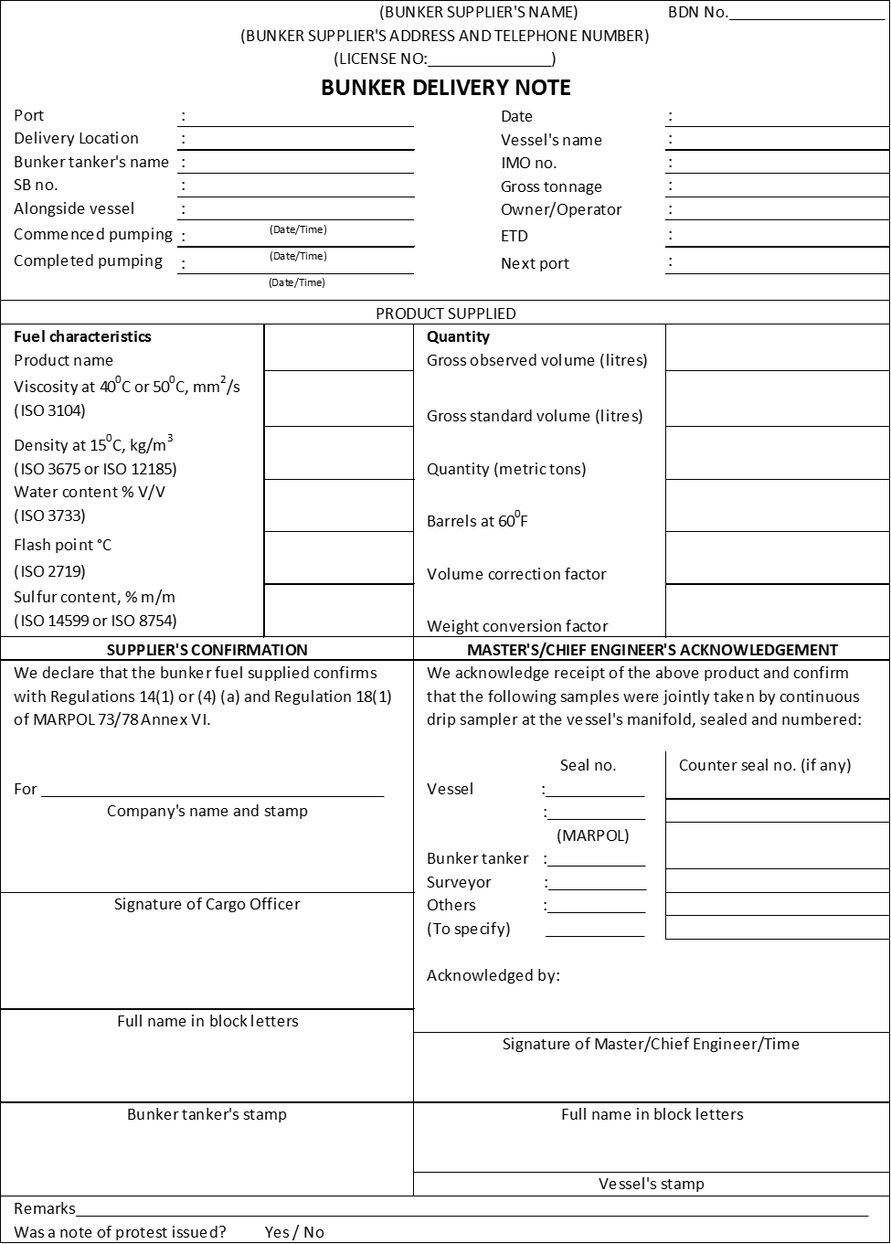
FOMP ANNEX B
Examples of hand signals for bunkering communication

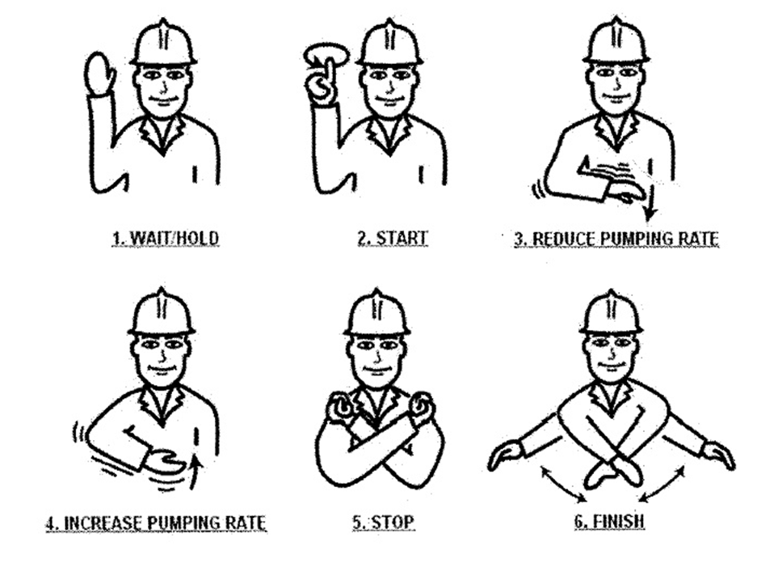

FOMP ANNEX C
Bunkering pre-delivery safety checklist
FOMP ANNEX D
Example of a sample label

Bunker Sample Label
Vessel’s name |  | IMO no.
Sampling date |  | Location
Supplier |  | Name of bunker tanker:
Sampling point:
□ Vessel manifold □ Bunker tanker manifold
Sampling method:
□ Continuous drip □ Others (please specify):
Grade: | Quantity MT:
Supplier’s seal no.: | Vessel’s seal no. (if applicable): |  | Surveyor’s seal no. (if applicable):
Cargo Officer | Chief Engineer |  | Bunker Surveyor
Name (in block letters) | Name (in block letters) |  | Name (in block letters)
Signature | Signature |  | Signature

FOMP ANNEX E
Example format of fuel sample tracking/control

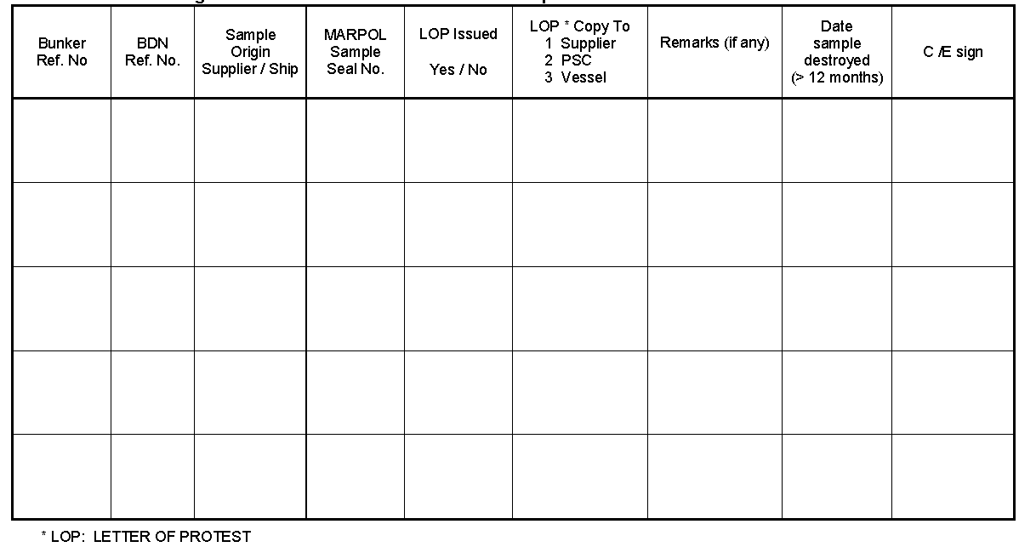

FOMP ANNEX F

Low Sulfur Fuel Oil Change-over Record for Regulated areas
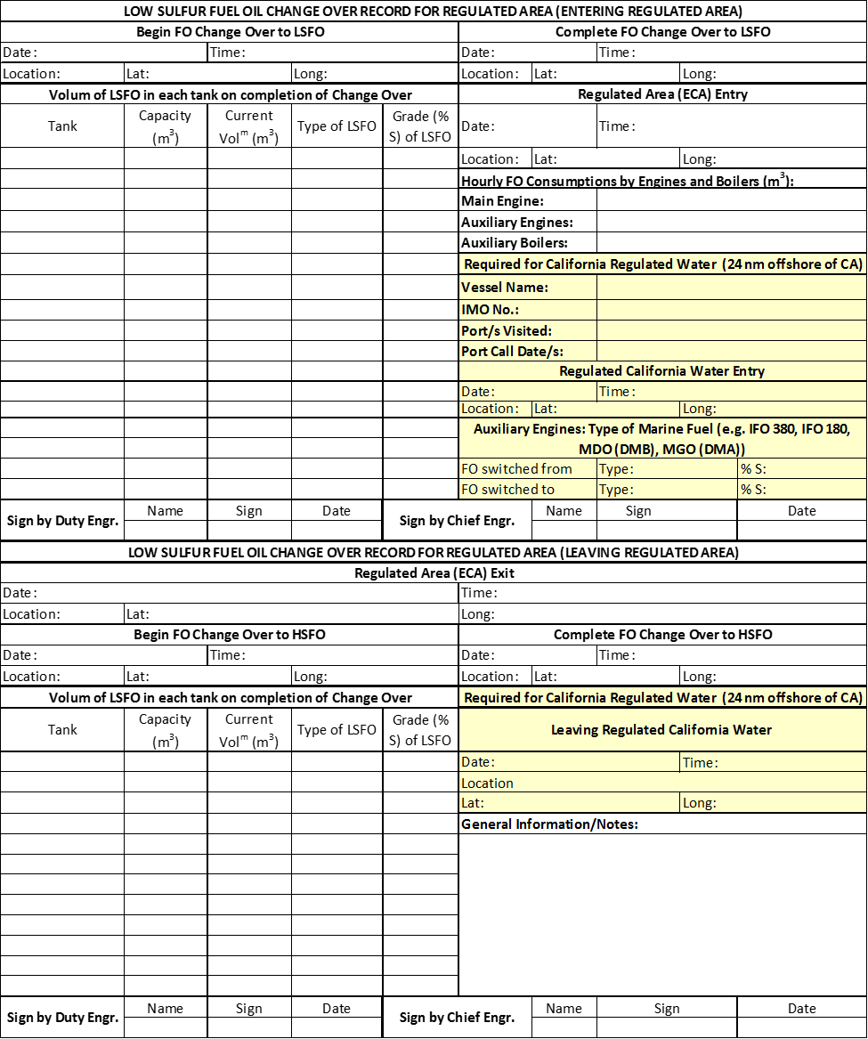

FOMP ANNEX G: Form OGV-3A
Recordkeeping Form—Fuel Switching Summary Form OGV-3A

Vessel Name & IMO #: Voyage:
Port/s Visited:
Port Call Date/s:
Fuel Switching Summary for Regulated California Waters – Main Engine/s
 |  |  |  |  | Main Engine Number/s2:
Ship Operation |  | Date (mo/day/yr) | Local Time (Pacific) | Location (Long & Lat) | Fuel #1 Type | Fuel #1  % Sulfur | Fuel #2 Type | Fuel #2  % Sulfur
Begin Fuel Switch (Should be prior to Entry to RCW1)
Complete Fuel Switch (Should be prior to
Entry to RCW1)
Entry to RCW1
Leave RCW1

Notes:
- RCW means Regulated California Waters as defined in the Ocean-Going Vessel Fuel Regulation. This is 24 nautical miles (nm) from the California shoreline, including 24 nm from the shoreline of the Channel Islands.
- For the main engine/s list the type of marine fuel (e.g. IFO 380, IFO 180, MDO(DMB), MGO(DMA) and percent by weight sulfur. Fuel #1 is the fuel that is being switched from, while fuel #2 is the fuel switched to. Add columns if different fuels apply to different main engines.
Recordkeeping Form—Fuel Switching Summary Form OGV-3A

Vessel Name & IMO #: Voyage:
Port/s Visited:
Port Call Date/s:

Fuel Switching Summary for Regulated California Waters – Auxiliary Engine/s
 |  |  |  |  | Auxiliary Engine Number/s2:
Ship Operation |  | Date (mo/day/yr) | Local Time (Pacific) | Location (Long & Lat) | Fuel #1 Type | Fuel #1  % Sulfur | Fuel #2 Type | Fuel #2  % Sulfur
Begin Fuel Switch (Should be prior to Entry to RCW1)
Complete Fuel Switch (Should be prior to
Entry to RCW1)
Entry to RCW1
Leave RCW1

Notes:
- RCW means Regulated California Waters as defined in the Ocean-Going Vessel Fuel Regulation. This is 24 nautical miles (nm) from the California shoreline, including 24 nm from the shoreline of the Channel Islands.
- For the auxiliary engine/s list the type of marine fuel (e.g. IFO 380, IFO 180, MDO(DMB), MGO(DMA) and percent by weight sulfur. Fuel #1 is the fuel that is being switched from, while fuel #2 is the fuel switched to. Add columns if different fuels apply to different auxiliary engines.

Recordkeeping Form—Fuel Switching Summary Form OGV-3A

Vessel Name & IMO #: Voyage:
Port/s Visited:
Port Call Date/s:

Fuel Switching Summary for Regulated California Waters – Auxiliary Boilers
 |  |  |  |  | Boiler Number/s2:
Ship Operation |  | Date (mo/day/yr) | Local Time (Pacific) | Location (Long & Lat) | Fuel #1 Type | Fuel #1  % Sulfur | Fuel #2 Type | Fuel #2  % Sulfur
Begin Fuel Switch (Should be prior to Entry to RCW1)
Complete Fuel Switch (Should be prior to
Entry to RCW1)
Entry to RCW1
Leave RCW1

Notes:
- RCW means Regulated California Waters as defined in the Ocean-Going Vessel Fuel Regulation. This is 24 nautical miles (nm) from the California shoreline, including 24 nm from the shoreline of the Channel Islands.
- For boiler/s list the type of marine fuel (e.g. IFO 380, IFO 180, MDO(DMB), MGO(DMA) and percent by weight sulfur. Fuel #1 is the fuel that is being switched from, while fuel #2 is the fuel switched to. Add columns if different fuels apply to different boilers.


CONTACT INFORMATION

North America Region
1701 City Plaza Dr.
Spring, Texas 77389, USA
Tel: +1-281-877-6000
Email: ABS-Amer@eagle.org

South America Region
Rua Acre, nº 15 - 11º floor, Centro
Rio de Janeiro 20081-000, Brazil
Tel: +55 21 2276-3535
Email: absrio@eagle.org

Europe Region
111 Old Broad Street
London EC2N 1AP, UK
Tel: +44-20-7247-3255
Email: ABS-Eur@eagle.org

Africa and Middle East Region
Al Joud Center, 1st floor, Suite # 111
Sheikh Zayed Road
P.O. Box 24860, Dubai, UAE
Tel: +971 4 330 6000
Email: ABSDubai@eagle.org

Greater China Region
World Trade Tower, 29F, Room 2906
500 Guangdong Road, Huangpu District,
Shanghai, China 200000
Tel: +86 21 23270888
Email: ABSGreaterChina@eagle.org

North Pacific Region
11th Floor, Kyobo Life Insurance Bldg.
7, Chungjang-daero, Jung-Gu
Busan 48939, Republic of Korea
Tel: +82 51 460 4197
Email: ABSNorthPacific@eagle.org

South Pacific Region
438 Alexandra Road
#08-00 Alexandra Point, Singapore 119958
Tel: +65 6276 8700
Email: ABS-Pac@eagle.org

© 2024 American Bureau of Shipping. All rights reserved.

